

Configuration of the DoubleClue KeePass Plug-in



# Introduction

The DoubleClue KeePass plug-in stores and loads '.kdbx files' in and from DoubleClue CloudSafe, a high-security cloud that protects data with multi-factor authentication. Push Approval, a user-friendly and secure MFA method, is available through the DoubleClue app, which can be downloaded from the App Store and Google PlayStore. In addition, DoubleClue 7 supports other authentication methods such as QR code scan, FIDO and SMS.

By storing their KeePass files in CloudSafe, DoubleClue users can edit them in the DoubleClue app and in DoubleClue UserPortal. In UserPortal, you can also save and manage the files together with other DoubleClue users.

Advantages:

* KeePass files are no longer accessed by just entering a password, but are protected with DoubleClue's secure multi-factor authentication.
* When the data is saved centrally with DoubleClue, the already encrypted KeePass file is encrypted once more.
* Users can access their KeePass file in DoubleClue PasswordSafe at any time via the DoubleClue UserPortal and or the DoubleClue app

Requirements:

* KeePass Password Safe 2.4.0 or higher
* DoubleClue Enterprise Management-Systems (DCEM) with registered users

# Implementation oft he DoubleClue KeePass-Plug-in

## Installation

1. Download the current KeePass version from https://keepass.info and install KeePass Password Safe according to the instructions of the provider.
2. Download the DoubleClue KeePass plug-in from https://keepass.info/plugins.html.
3. Go to the directory where you installed KeePass Password Safe and save the **"DoubleClue KeePass Plugin"** in the **"Plugins"** folder.

To check if the plug-in is active, open KeePass. The **"DoubleClue KeePass Plugin"** is now displayed under "Tools"> "Plugins".

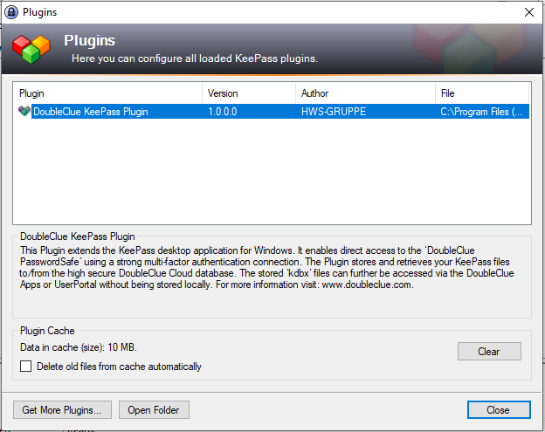

## Connection

By default, the plug-in connects to DoubleClue CloudSafe at <https://doubleclue.online>. All private DoubleClue users who created their account at https://doubleclue.online can use this standard connection.

Enterprise users must first configure their plug-in so that it connects successfully to their company DoubleClue. Weitere Informationen finden Sie ihn Kapitel 3. Konfiguration für Firmenbenutzer.

For more information see Chapter 3. Configuration for Enterprise Users.

## Configuration for Enterprise Users

The following instructions are for DCEM administrators who want to connect the DoubleClue KeePass plug-in to an enterprise installation of DoubleClue. For the configuration you need two files from your DoubleClue Enterprise Management: **“SdkConfig.dcem”** and **“AuthConnector.dcem”**.

C:\Users\maike.behnsen\Desktop\Grafiken\caution-sign.pngTo create and download these files, you must log in to DCEM as an administrator. If you do not have administrator access, please contact your company's DCEM administrator.

### Creating the „SdkConfig.dcem“ File

1. In DCEM, go to the main menu item "Identity Management", submenu "Versions" and click on "Generate SDK configuration".
2. Usually, the URL is inserted automatically. If this is not the case, enter the URL as follows:

**wss:// *--Hostname/IP of the Server--* : *--Port of the Server--* /dcem/ws/appConnection**

1. Click on **“Download SDK Configuration”** to receive the **“SdkConfig.dcem”** file.

### Creating the „AuthGatewayConfig.dcem“ File

1. In DCEM, go to the main menu item "Identity Management", submenu "Auth-Connector" and click on "Add".
2. Enter a unique name, e.g. DoubleClue Keepass Plugin, and click OK.
3. Click the "Download" button to download the "AuthConnector.dcem" file.

### Setting up the Configuration on a Computer

The configuration files must be properly stored on the computer in order to connect the DoubleClue KeePass plug-in with the enterprise DoubleClue. The location where they are saved differs depending on whether you want all users of the computer to connect to the same DCEM or different users to use different DCEMs.

### Configuration Setup for all Users of a Computer

1. Go to the KeePass installation directory and create a new folder called **“DoubleClueAuthConnector”**.
2. Copy the files **“AuthConnector.dcem”** and **“SdkConfig.dcem”** into the new folder **“DoubleClueAuthConnector”**.
3. Restart KeePass.

The DoubleClue KeePass plug-in can now be used.

### Configuration Setup for a Specific User of a Computer

1. Go to the user directory, usually C:\Users\john.smith.
2. Create a new folder called “**DoubleClueAuthConnector**”.
3. Copy the files “**AuthConnector.dcem**” and “**SdkConfig.dcem**” into the new folder “DoubleClueAuthConnector”.
4. Restart KeePass.

The DoubleClue KeePass plug-in can now be used.

C:\Users\maike.behnsen\Desktop\Grafiken\caution-sign.png The plug-in always looks for the user folder first. If DoubleClueAuthConnector folders have been created and the corresponding files have been stored in both directories, the plug-in always connects to the DCEM, whose files are stored in the user folder.

### Connection to Several DCEMs

It is possible to connect to several DCEMs from the same computer by configuring the plug-in as follows:

1. Create multiple subfolders in the “DoubleClueAuthConnector” folder and give each one a unique name.
2. Copy the files with the configuration files for the different DCEMs into the different subfolders.
3. Select a DCEM by adding the name of the corresponding sub-folder as a suffix to your user name with a dollar sign ($) separated from the user name. For example: Username $ foldername.

By using different suffixes, you can connect to different DCEMs.

# Using the DoubleClue KeePass plug-in

## Open the KeePass file with DoubleClue

1. Open KeePass.
2. Click in the upper left menu on „File“ > „Open“ > „Open with DoubleClue“.

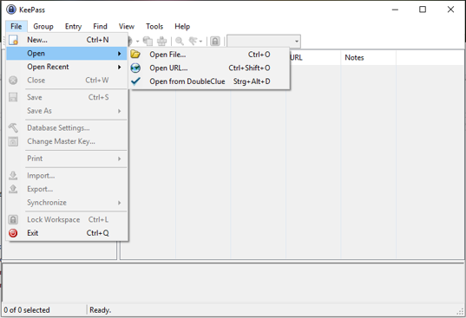

1. A login window will open. Log in with your DoubleClue credentials.

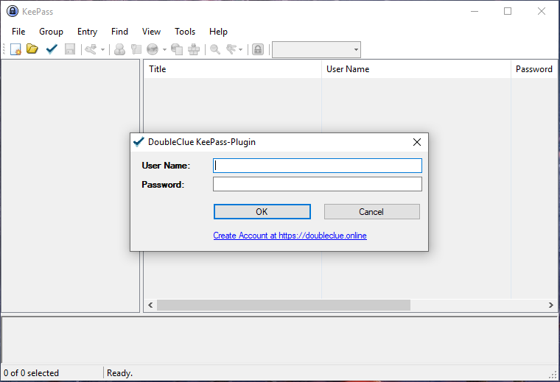

1. Select the authentication method you want to use to connect to DoubleClue. You can set the valid authentication methods in DCEM under "Identity Management"> "Policies"> "Applications".

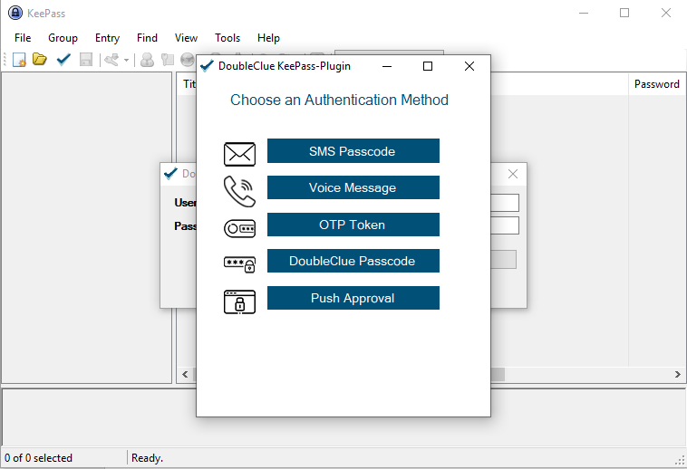

## Store a KeePass file in DoubleClue

Click File > Save As > Save to DoubleClue in the top left menu to save your KeePass file to the DoubleClue cluster.

If you only want to save a copy of the file in DoubleClue, click on "Save copy in DoubleClue".

Then log into DoubleClue via the KeePass plug-in as described in section 3.1, steps 3 and 4.